Take-Home Case Study: Shock Calibration Under Data Constraints
Take 50 years of historical data for the S&P 500 daily Close value.
Part A — Full-history calibration
Using the full 50 years of daily data:
- Choose and justify an appropriate shock definition/metric for this series.
- Calibrate 1-month, 3-month, and 6-month adverse shocks at the 90th, 95th, and 99th percentile severities.
- Compare the shocks across horizons and severities and explain the conclusions you draw.
For Part A:
The metrics that comes to my mind are: Rolling buy-and-hold metric – everyday I would buy and hold for a fixed horizon -> rank from worse to best -> get the tail related metrics or VaR like shocks and expected shortfall information for both down and up shocks (a common process in historical simulation risk metric)
Another metric is a path dependent one which I utilize more at my current firm: Drawdown (peak to trough) but becomes harder to compare with missing data in parts B and C so would avoid
For the comparison on shocks some statements to answer with the above approach:
• how shock magnitude changes from 1m to 3m to 6m,
• how it changes from 90 to 95 to 99,
• whether the increase is proportional or nonlinear,
• what that says about tail behavior, persistence, and crisis episodes.

I would do a robust check with the following: Conditional EVT (Extreme Value Theory): Fit a GARCH model first to capture dynamic volatility clustering. Then, apply an EVT framework exclusively to the standardized residuals to find true tail risk.
For the comparison on shocks some statements to answer:
• clustering of shocks/tails

Part B — Monthly point-in-time history for first 40 years
Now assume the first 40 years of the sample are available only as end-of-month observations, while the last 10 years remain available at daily frequency.
Develop and implement a method to estimate the same 1-month, 3-month, and 6-month shocks under this data limitation.
Your approach should address the fact that higher-frequency information is unavailable for most of the sample, and should aim to infer shock estimates that are as comparable as possible to those from Part A. If you have multiple approaches at least one of them should be the construction/simulation of daily data.
Explain:
- your methodology,
- key assumptions,
- limitations,
- why you believe the approach is reasonable,
- and how the results compare with Part A.
For Part B:
Q. Develop and implement a method to estimate the same 1-month, 3-month, and 6-month shocks under this data limitation. (TAIL ESTIMATION)
The following steps:
- Construct month-end horizon returns and convert to losses
- Choose Threshold
- Fit a Generalized Pareto Distribution to losses above threshold (Extreme Value Theorem).
- Use the fitted tail to estimate the desired adverse quantiles.
If you have multiple approaches at least one of them should be the construction/simulation of daily data. (DAILY CONSTRUCTION ESTIMATION)
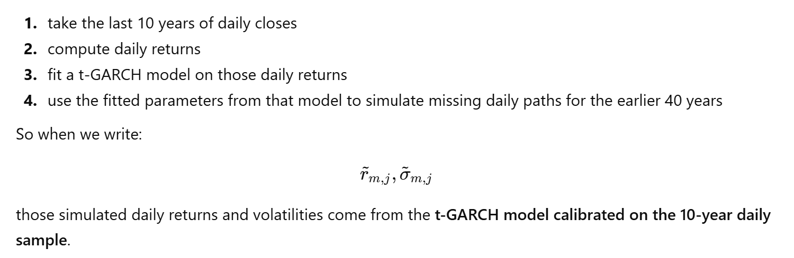
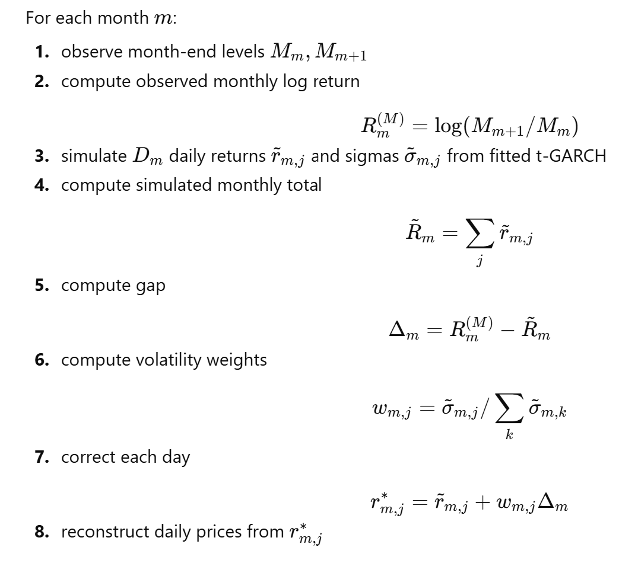
9. Repeat the above process multiple times to get average simulated paths + an estimate of drawdowns for each horizon and percentiles
Based on the above I will explain the assumptions, limitations and why it seems reasonable.

Part C — Monthly averages instead of month-end observations
Now assume that, for the first 40 years, the data consists of monthly average values rather than month-end values.
Again, develop and implement an approach to estimate the same shocks (again if multiple approaches at least one of them should be the construction/simulation of daily data), explain your assumptions and limitations, and compare the results with Parts A and B.
For Part C:
Use the last 10 years, where you have daily data, to learn the relationship between:
- monthly averages,
- month-end levels,
- and month-end returns.
Via a simple empirical distribution, or a regression on monthly-average returns
Then apply logic from Part B: TAIL ESTIMATION + DAILY CONSTRUCTION ESTIMATION

Part D — AI-assisted workflow
Use at least one AI tool to support your work. Document:
- which tool(s) you used,
- how you used them,
- examples of prompts or workflow,
- what outputs were useful,
- and how you validated the results before relying on them.

Deliverables
Please prepare:
- A presentation suitable for Market Risk Analytics:
  - 20 minutes for the case presentation
  - plus readiness for approximately 10 minutes of discussion on code and AI usage
- Python code used in your analysis, with sufficient structure and documentation to support a short walkthrough
- Prompt set used in your analysis, with sufficient structure and documentation to support a short walkthrough
The presentation will be followed by approximately 15-30 minutes of questions.

